УО «Белорусский государственный университет информатики и

радиоэлектроники»

Кафедра ПОИТ

Отчет по лабораторной работе № 3.1

по предмету

Основы Алгоритмизации и Программирования

Вариант 4

Выполнил

Воривода М.А.

Проверила

Данилова Г.В.

Группа:

951007

Минск 2019

**Задание**

Определить номер позиции k-го вхождения строки st1 в строку st2.

Если такого нет, возвратить 0.

**Код программы**

**(Delphi)**

program Goal1;

{$APPTYPE CONSOLE}

{$R *.res}

uses

System.SysUtils;

function Definition(St1, St2 : String; K : Integer) : Integer;

var

DeletedLength : Integer;

begin

DeletedLength := 0;

while (K > 1) and (pos(St1, St2) > 0) do

begin

DeletedLength := DeletedLength + pos(St1, St2) +

Length(St1) - 1;

delete(St2, 1, pos(St1, St2) + Length(St1) - 1);

dec(K);

end;

if pos(st1, st2) = 0 then

Definition := 0

else

Definition := pos(St1, St2) + DeletedLength;

end;

procedure InputData(var St1, St2 : String; var K : Integer);

var

InValid : Boolean;

begin

InValid := false;

WriteLn('Enter St1: ');

ReadLn(St1);

WriteLn('Enter St2: ');

ReadLn(St2);

repeat

try

WriteLn('Enter K: ');

ReadLn(K);

InValid := true;

except

WriteLn('INPUT ERROR');

end;

until InValid;

end;

procedure InputDataFromFile(var St1, St2 : String; var K : Integer); { Ввод данных с файла }

var

InF : TextFile;

InValid : Boolean;

Reader : String;

begin

InValid := false;

repeat

try

WriteLn('Enter path to input file: ');

ReadLn(Reader);

AssignFile(InF, Reader);

Reset(InF);

InValid := true;

except

WriteLn('INPUT ERROR');

end;

until InValid;

ReadLn(InF, St1);

ReadLn(InF, St2);

try

ReadLn(InF, K);

except

WriteLn('INPUT ERROR');

InValid := false;

end;

if InValid then

begin

WriteLn('Entered St1: ', St1);

WriteLn('Entered St2: ', St2);

WriteLn('Entered K: ', K);

end;

Close(InF);

end;

procedure OutputData(Answer : Integer);

var

OutF : TextFile;

Reader : String;

begin

WriteLn('Enter path to output file: ');

ReadLn(Reader);

AssignFile(OutF, Reader);

Rewrite(OutF);

WriteLn(OutF, Answer, ' - Answer');

WriteLn(Answer, ' - Answer');

Close(OutF);

end;

procedure Main();

var

St1, St2 : String;

K : Integer;

Reader : Char;

InValid : Boolean;

begin

WriteLn('This program defines index of k-th match of St1 in

St2. If there are no matches it should return 0' +

#13#10);

InValid := false;

repeat

WriteLn('Enter "C" if you want to input data from

console or' + #13#10 + '"F" if you want to input

data from file');

ReadLn(Reader);

case Reader of

'C' :

begin

InputData(St1, St2, K);

InValid := true;

end;

'F' :

begin

InputDataFromFile(St1, St2, K);

InValid := true;

end;

end;

until InValid;

OutputData(Definition(St1, St2, K));

ReadLn;

end;

begin

Main();

end.

**Код программы**

**(C)**

#include <stdio.h>

#include <string.h>

int inputData(char *st1, char *st2) {

int k;

printf("Enter St1: \n");

fflush(stdin);

fgets(st1, 100, stdin);

printf("Enter St2: \n");

fgets(st2, 100, stdin);

fflush(stdin);

printf("Enter K: \n");

scanf("%d", &k);

return k;

}

int inputDataFromFile(char *st1, char *st2) {

int k;

FILE *inF = fopen("D:\\University\\OAiP\\LAB3\\Goal

1\\C\\goal\\input.txt", "r");

fgets(st1, 100, inF);

fgets(st2, 100, inF);

fscanf(inF, "%d", &k);

printf("Entered St1: %sEntered St2: %sEntered K: %d\n" ,

st1, st2, k);

fclose(inF);

return k;

}

void substr(char *temp, char *st2, int begin, int end) {

int j = 0;

for (int i = begin; i < end; i++) {

temp[j] = st2[i];

j++;

}

temp[j] = '\0';

}

int definition(char *st1, char *st2, int k) {

int term = strlen(st2) - strlen(st1) + 1, j = 0;

char temp[strlen(st1) + 1];

while ((j < term) && (k > 1)) {

substr(temp, st2, j, (j + strlen(st1)));

if (strcmp(st1, temp) == 0) {

k--;

}

j++;

}

for (j; j < term; j++) {

substr(temp, st2, j, (j + strlen(st1)));

if (strcmp(st1, temp) == 0) {

return j + 1;

}

}

return 0;

}

void outputData(int answer) {

FILE *outF = fopen("D:\\University\\OAiP\\LAB3\\Goal

1\\C\\goal\\output.txt", "w");

fprintf(outF, "%d - answer", answer);

printf("%d - answer", answer);

fclose(outF);

}

void main() {

char st1[101], st2[101];

char choice;

int k = 0, valid = 1;

printf("This program defines index of k-th match of St1 in

St2 (length of St1 and St2 not bigger than 100).

\nIf there are no matches it should return 0 \n\n");

do {

printf("Enter \"C\" if you want to input data from

console or \n\"F\" if you want to input data

from file:\n");

fflush(stdin);

scanf("%c", &choice);

switch (choice) {

case 'C' :

k = inputData(st1, st2);

valid = 0;

break;

case 'F' :

k = inputDataFromFile(st1, st2);

valid = 0;

break;

}

} while (valid);

st1[strlen(st1) - 1] = '\0';

st2[strlen(st2) - 1] = '\0';

outputData(definition(st1, st2, k));

}

**Код программы**

**(Java)**

import java.util.Scanner;

import java.io.*;

public class Main {

public static void main(String[] args) throws IOException {

Scanner in = new Scanner(System.in);

String st1 = "", st2 = "";

boolean valid = true;

String[] reader;

int k = 0;

System.out.println("This program defines index of k-th

match of St1 in St2. If there are no matches

it should return 0 \n");

do {

System.out.println("Enter \"C\" if you want to input

data from console or \n\"F\" if you want to

input data from file");

switch (in.nextLine()) {

case "C" :

reader = inputData();

st1 = reader[0];

st2 = reader[1];

k = Integer.parseInt(reader[2]);

valid = false;

break;

case "F" :

reader = inputDataFromFile();

st1 = reader[0];

st2 = reader[1];

k = Integer.parseInt(reader[2]);

valid = false;

break;

}

} while (valid);

outputData(definition(st1, st2, k));

}

public static String[] inputData() {

Scanner in = new Scanner(System.in);

String st1, st2, k;

System.out.println("Enter St1: ");

st1 = in.nextLine();

System.out.println("Enter St2: ");

st2 = in.nextLine();

System.out.println("Enter K: ");

k = in.nextLine();

return new String[] {st1, st2, k};

}

public static String[] inputDataFromFile() throws

IOException {

Scanner in = new Scanner(System.in);

String st1 = "", st2 = "", k = "";

boolean valid = true;

FileReader inF = new FileReader("input.txt");

do {

try {

System.out.println("Enter path to input file");

inF = new FileReader(in.nextLine());

Scanner fileScanner = new Scanner(inF);

st1 = fileScanner.nextLine();

st2 = fileScanner.nextLine();

k = fileScanner.nextLine();

valid = false;

} catch (Exception e) {

System.out.println("INPUT ERROR");

}

} while (valid);

System.out.println("Entered St1: " + st1 + "\nEntered

St2: " + st2 + "\nEntered K: " + k);

inF.close();

return new String[] {st1, st2, k};

}

public static int definition(String st1, String st2, int k){

int deletedLength = 0;

while ((k > 1) && (st2.indexOf(st1)) > -1) {

deletedLength += st1.length() + st2.indexOf(st1);

st2 = st2.replaceFirst(st2.substring(0,

st2.indexOf(st1)) + st1, "");

k--;

}

if (st2.indexOf(st1 < 0) {

return 0;

} else {

return st2.indexOf(st1) + deletedLength + 1;

}

}

public static void outputData(int Answer)throws IOException{

Scanner in = new Scanner(System.in);

System.out.println("Enter path to output file: ");

FileWriter outF = new FileWriter(in.nextLine());

outF.write(Answer + " - answer");

System.out.println(Answer + " - answer");

outF.close();

}

}

**Блок-схема**





**Работа программы**

**Delphi**

Input:

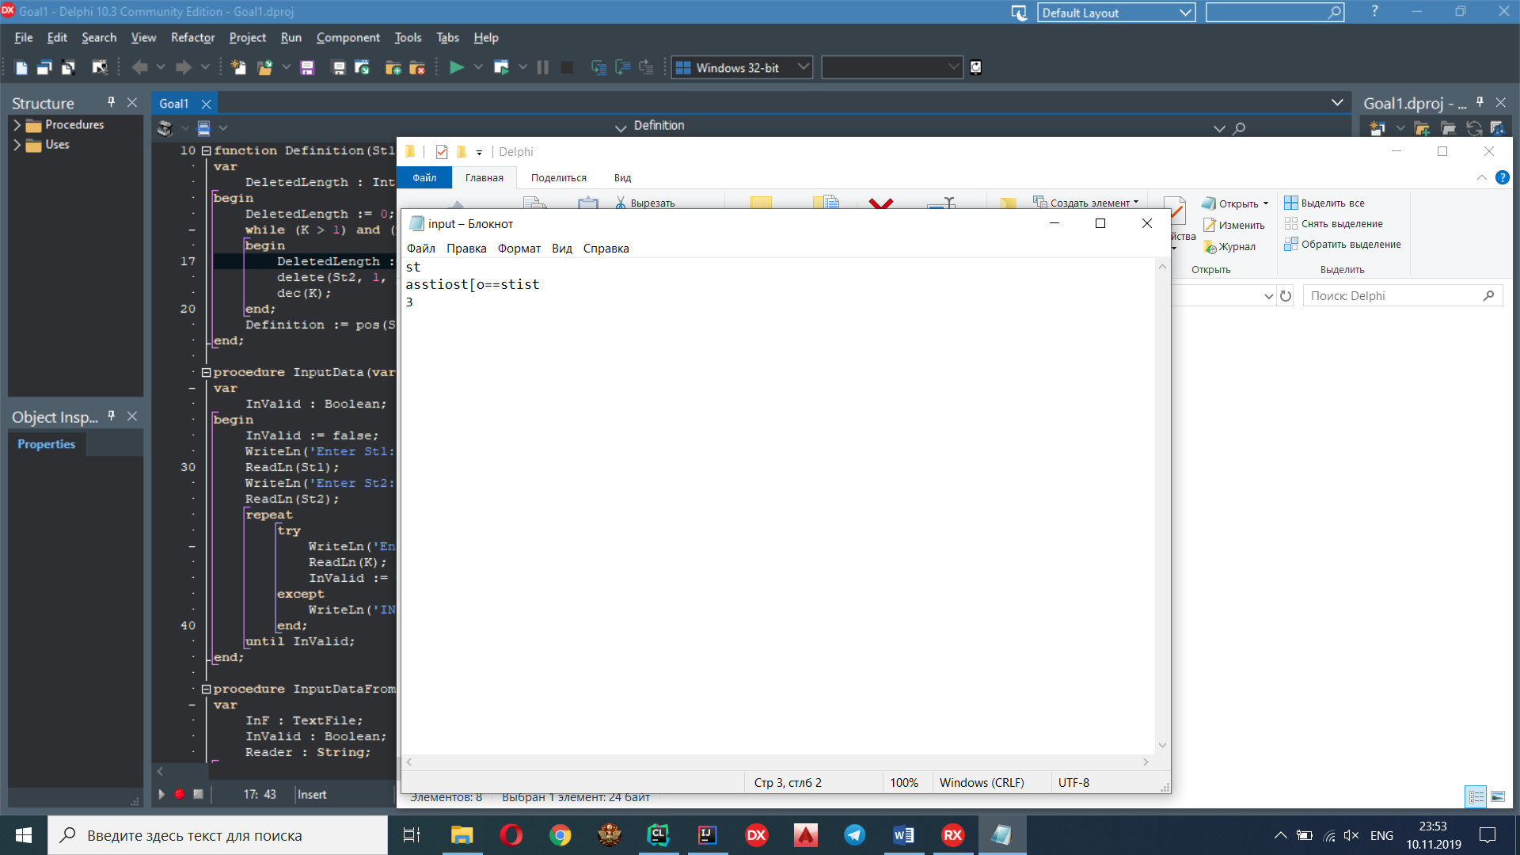

Output:

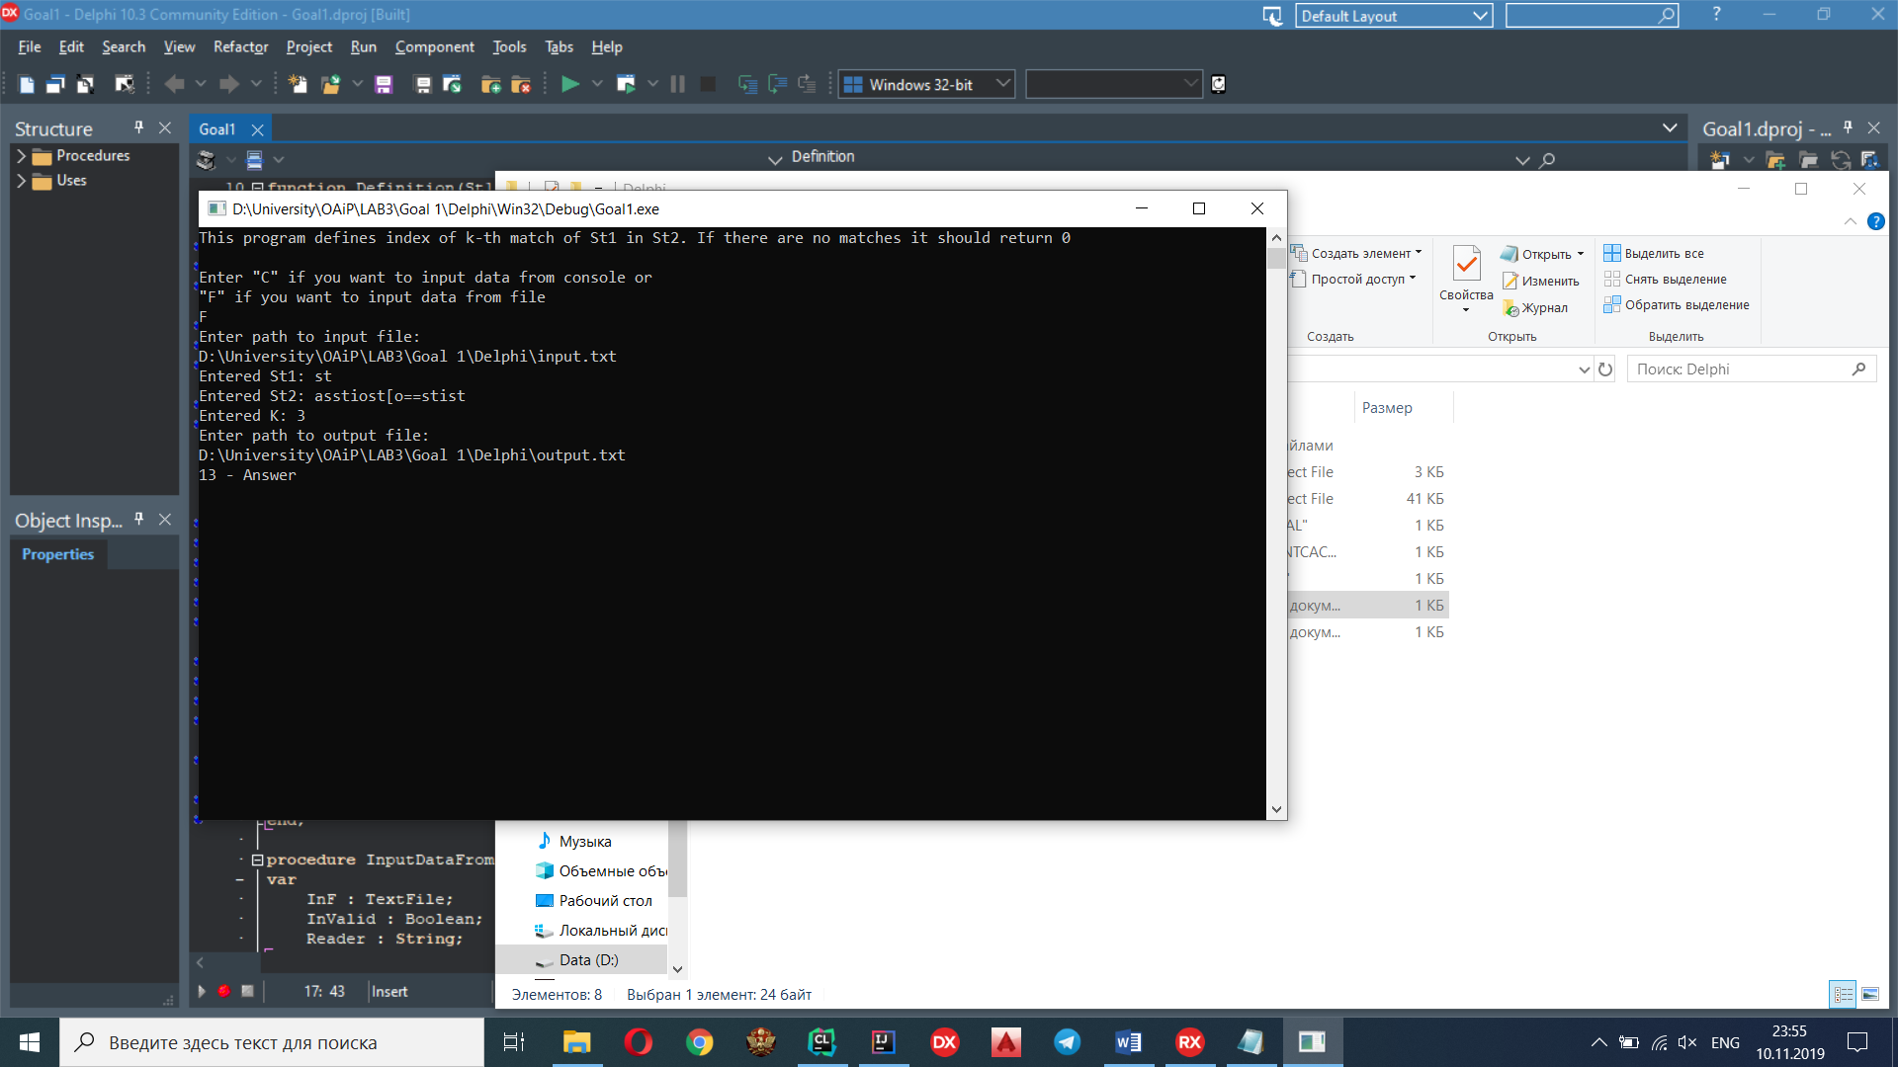

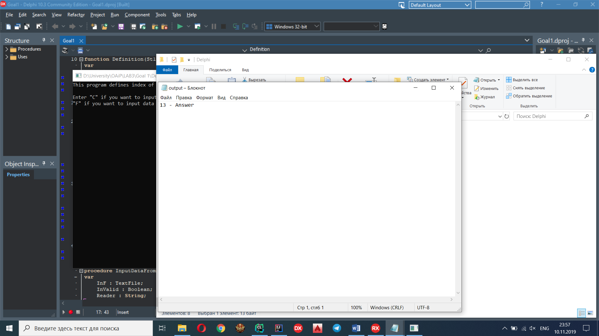

Console:

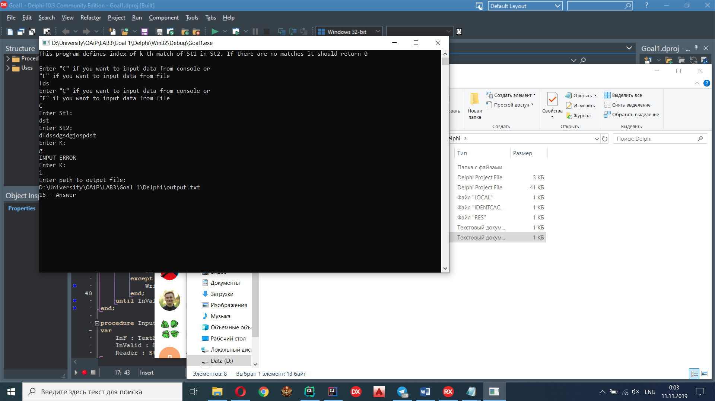

**C**

Input:

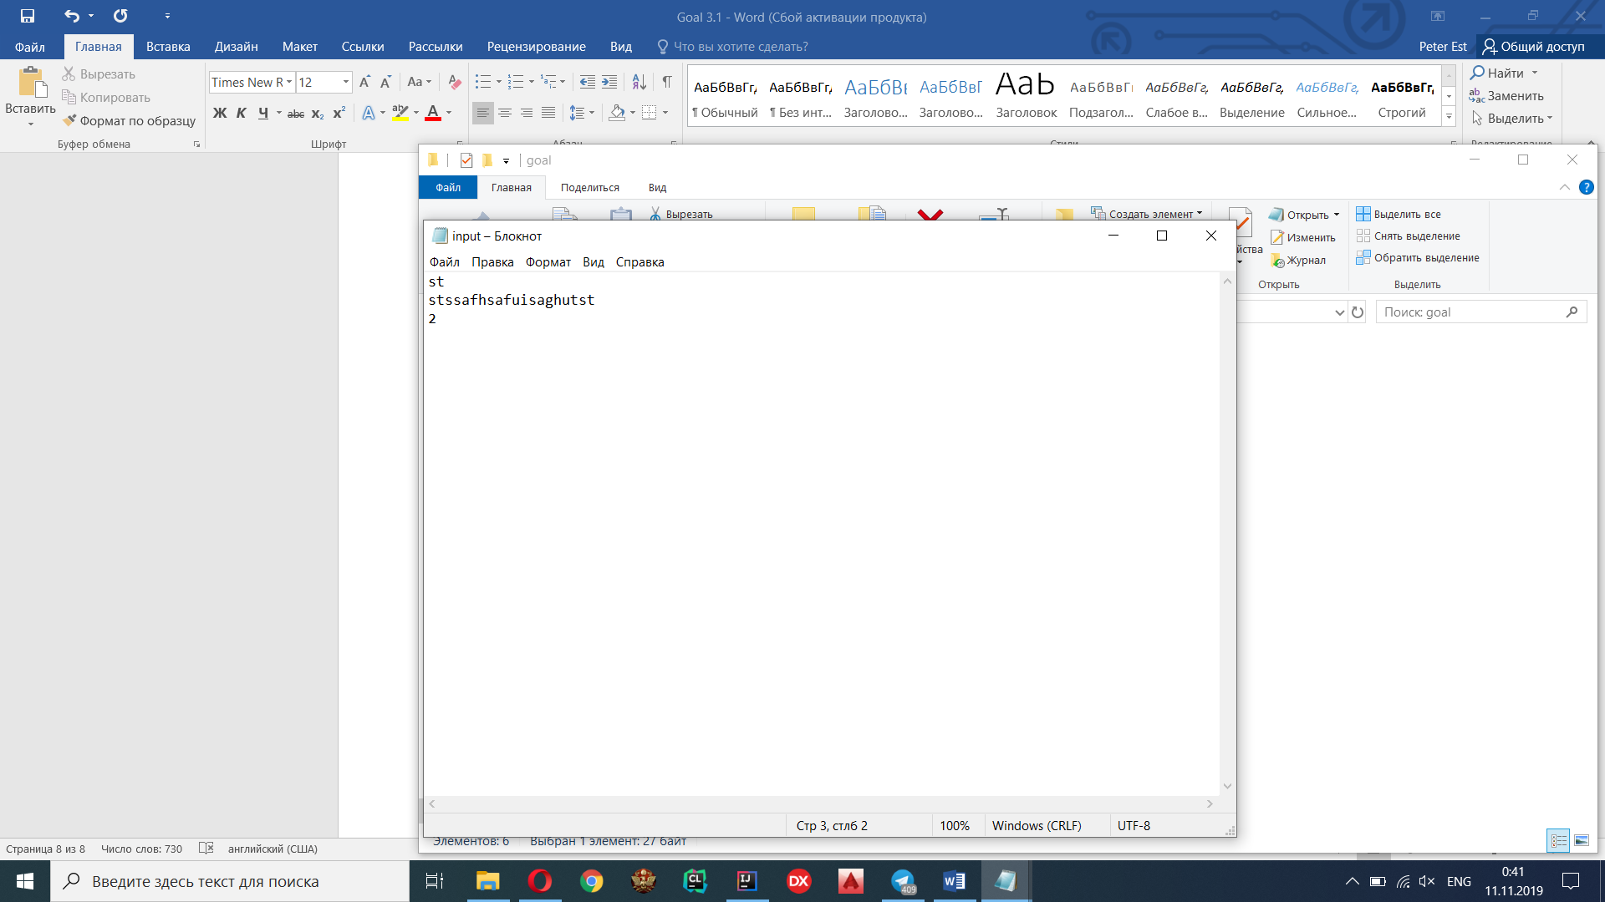

Output: 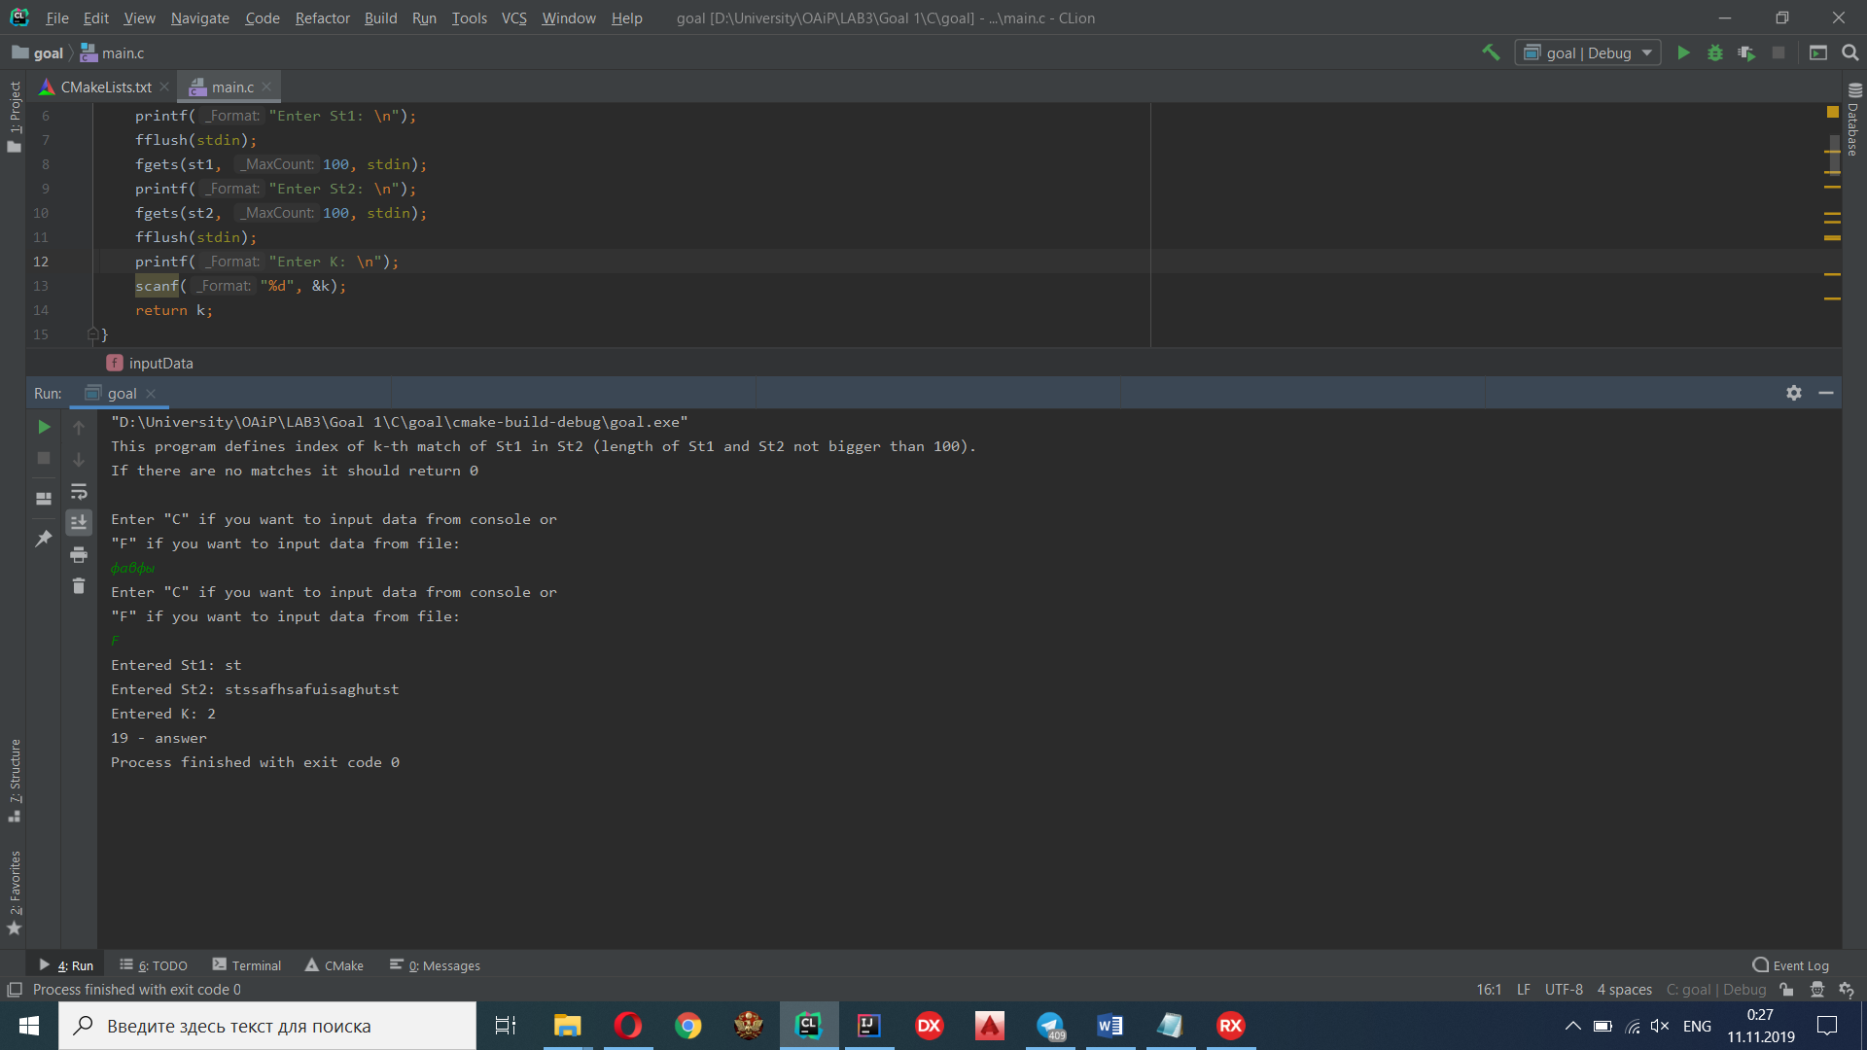

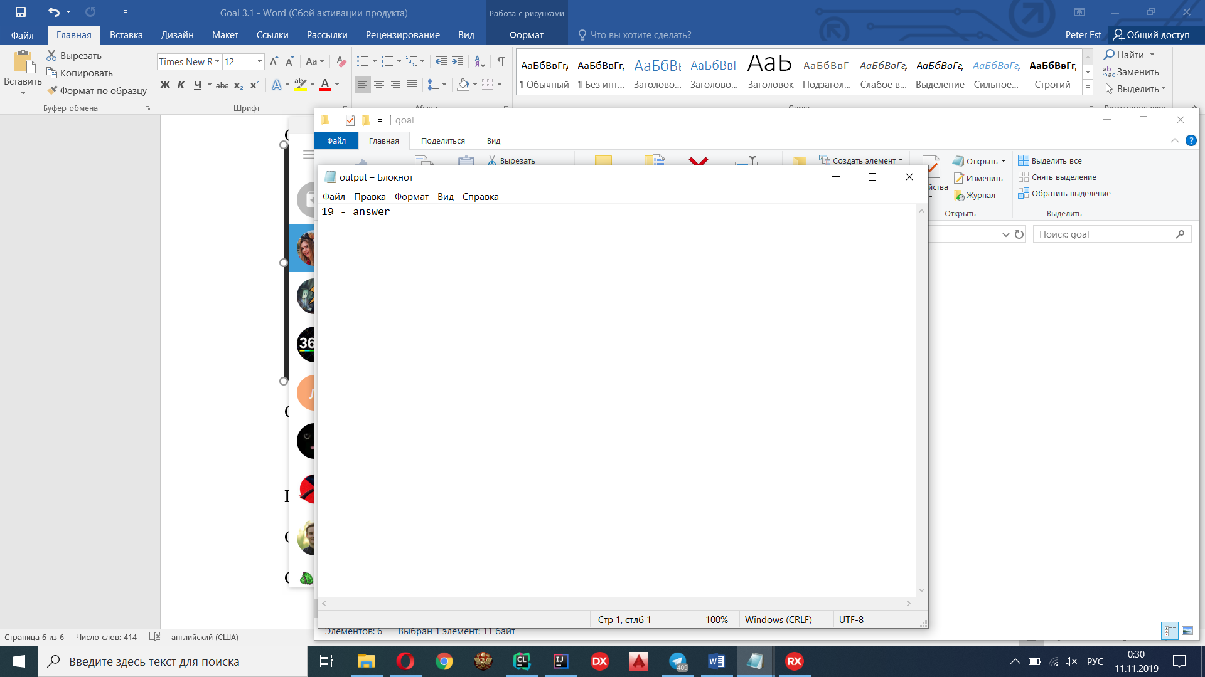

Console:

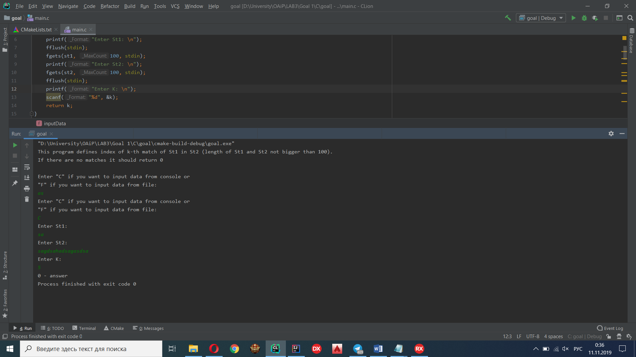

**Java**

Input:

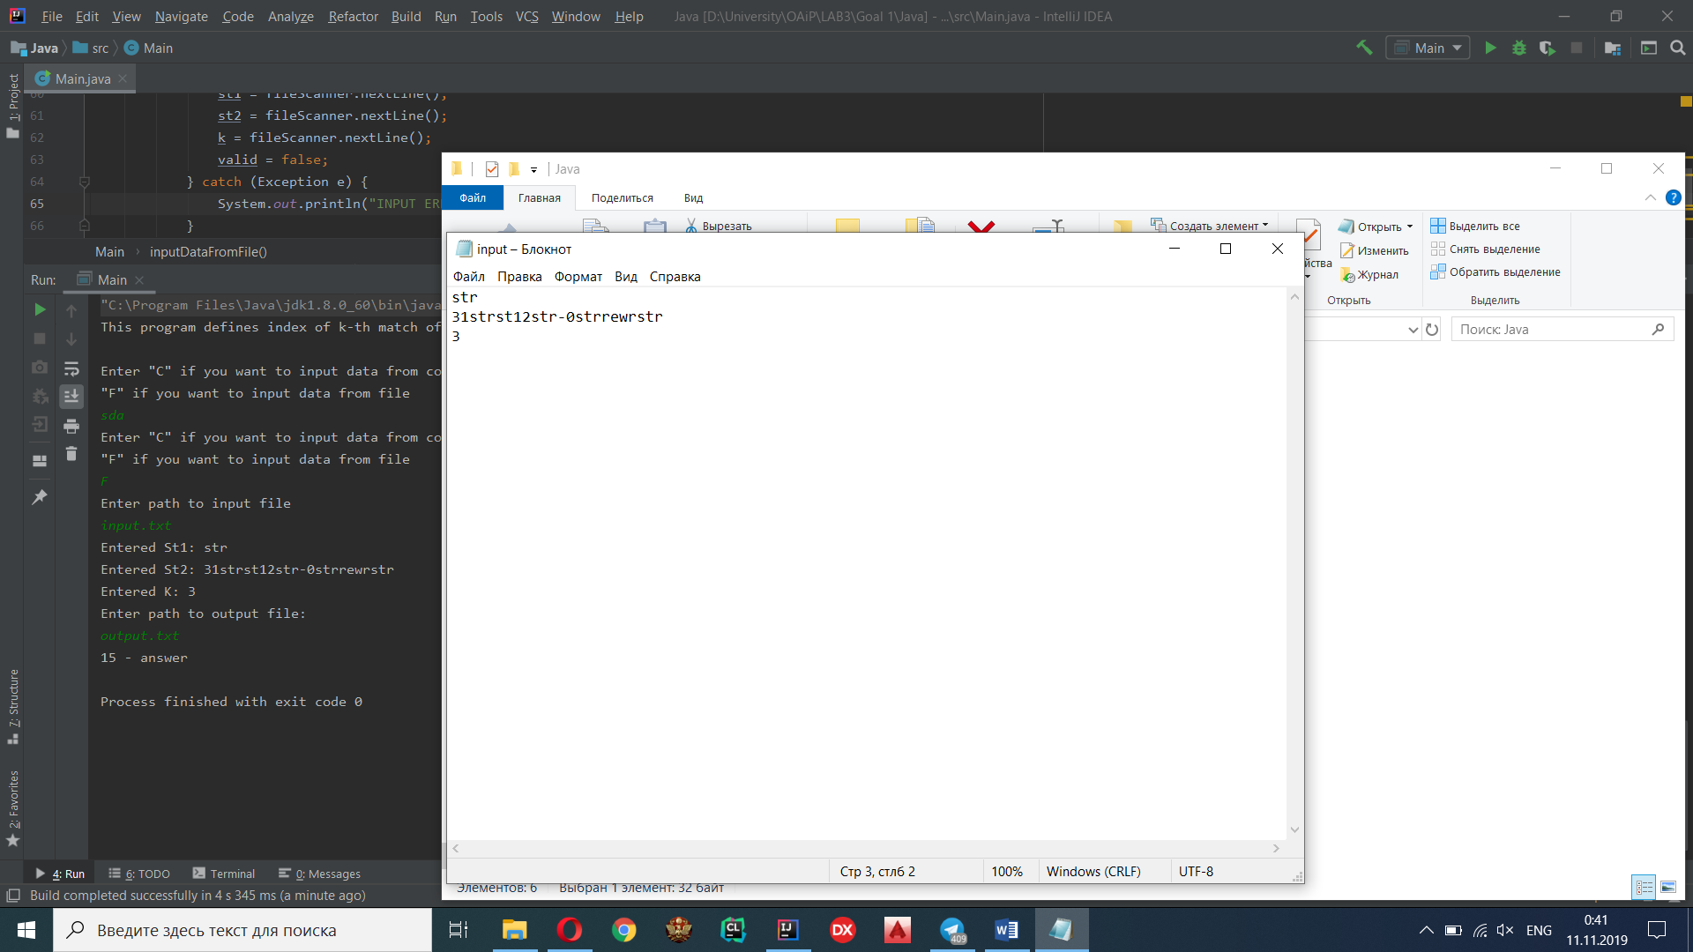

Output:

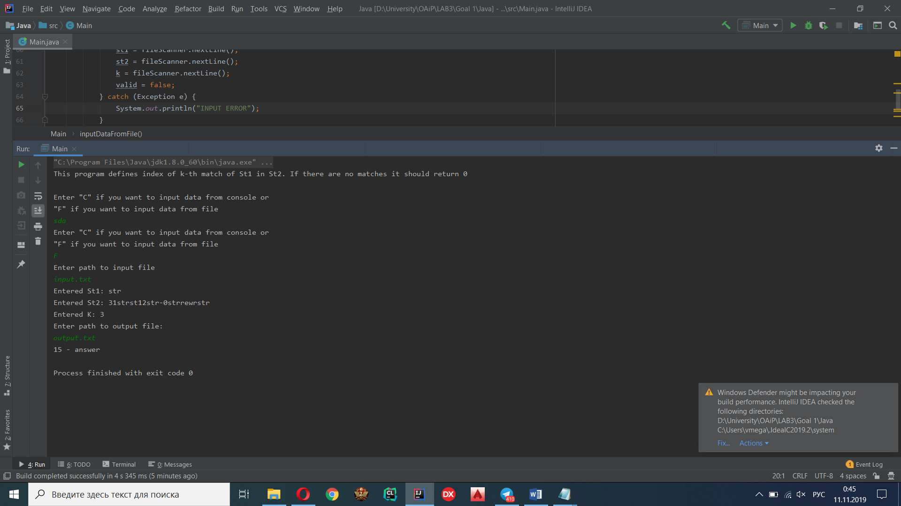

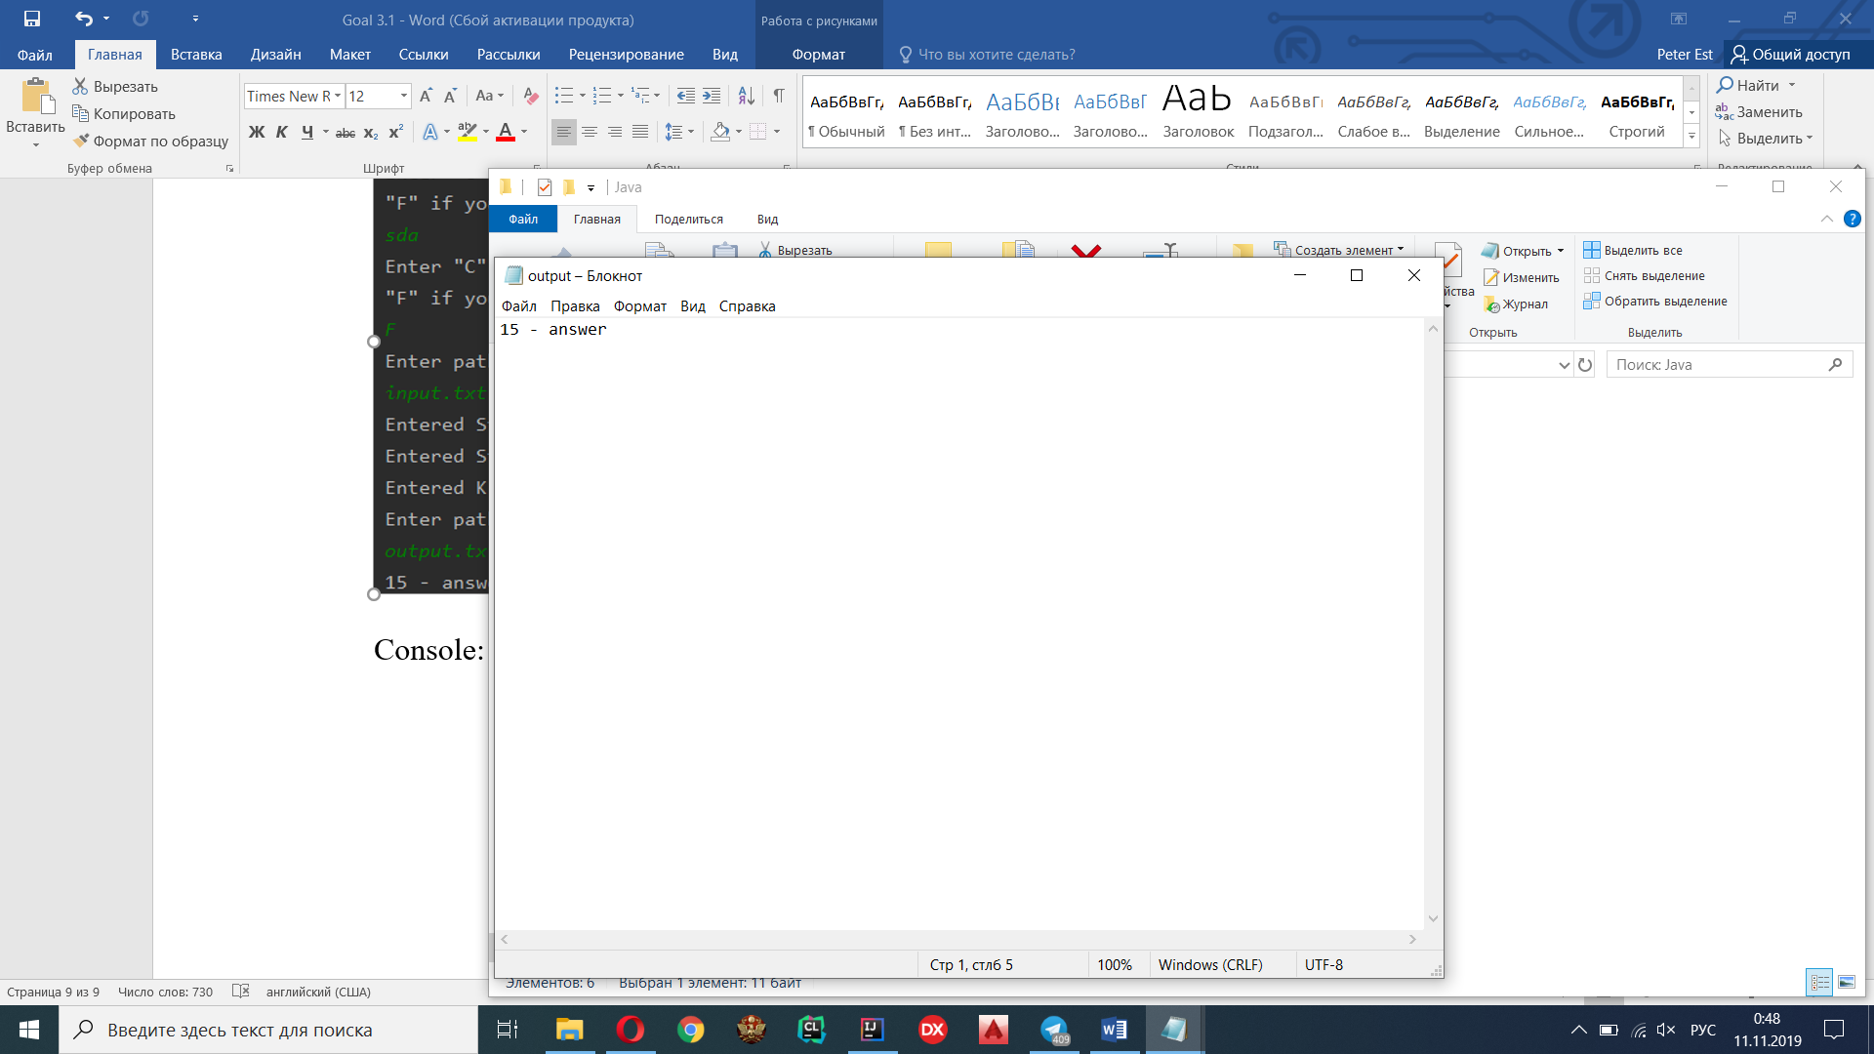

Console:

